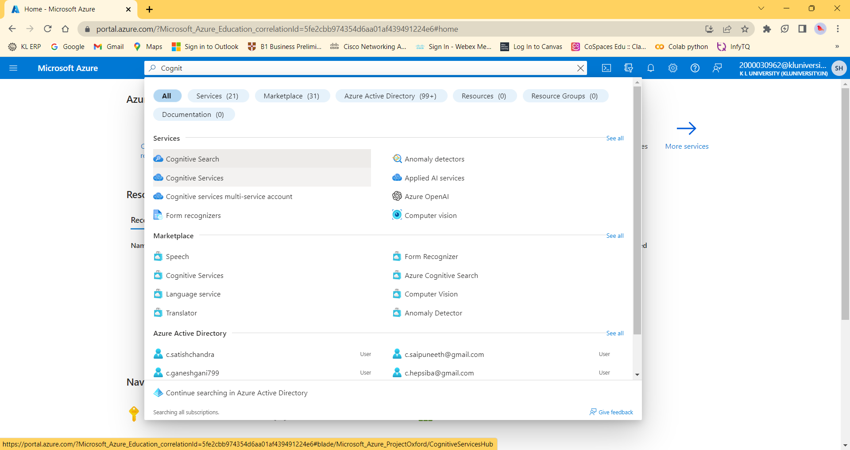

<https://imageprocessing-azure.cognitiveservices.azure.com/>

key1-98cfa0c3dcce488fa0db8abad83ffa1c

key2-8523f18b69494bb2988187b4376e8696



